**Nguyễn Kim Định - 1C22 – PCO 05**

**An overview of my mid-term project (Principle of computers class)**

Hello, my name is Nguyễn Kim Định (Kim for short), I’m a student from class 1C22, class PCO 05, Mr. Khoa. This is my report regarding the mid-term project for Principle of Computer class. This report will have 2 main parts: The first part will talk about the topic of my project and technologies that I used to create my project. And the second part will all about Result, which is the screen captures of my codes files and webpage (Both in normal form and responsive form.)

1. **Overview**
2. **Topic of the webpage**

The website I created is named 'Frost-Bite shop.' I chose this name because I've always found the name 'Frost-Bite' quite appealing, and I've been using it for various projects since my high school days. As for the idea behind this website, after reviewing the materials provided by our class and watching some idea videos on YouTube, as well as referencing some websites I know. I decided to recreate the Starbucks website in my own way. Due to time constraints and my limited coding abilities and I had to start from scratch, so I primarily used HTML and CSS to build my website. Additionally, I utilized various supporting tools to expedite my coding process, which I'll discuss in the following section.

1. **The technologies that I used to create my website**

* **HTML**: This is one of 2 main programming languages that I used to create my web. I used HTML to create texts, import images, insert links, create heading, body, and footer parts,….
* **CSS**: I also use this language to describes how my web will be and how the HTMl elements can be displayed on my screen and everyone screen
* **JavaScript**: I only used JavaScript only a little bit to create the hamburger menu which used for mobile version of my web
* **Chat Gpt, Bing AI**: I used these two AI to ask them how to create some parts of my page, such as: “How to create footer using html and css, How to insert texts on an image using html and css,…..”. These two helped me a lot since my friends are not always have free time so these became my two teachers
* **Youtube videos**: Yes, I have been searching a lot of youtube videos about how to write codes, how to use css elements, to create my body, to learn how to use class and id in html the most effective way.

1. **Result** 
   1. **Code files**

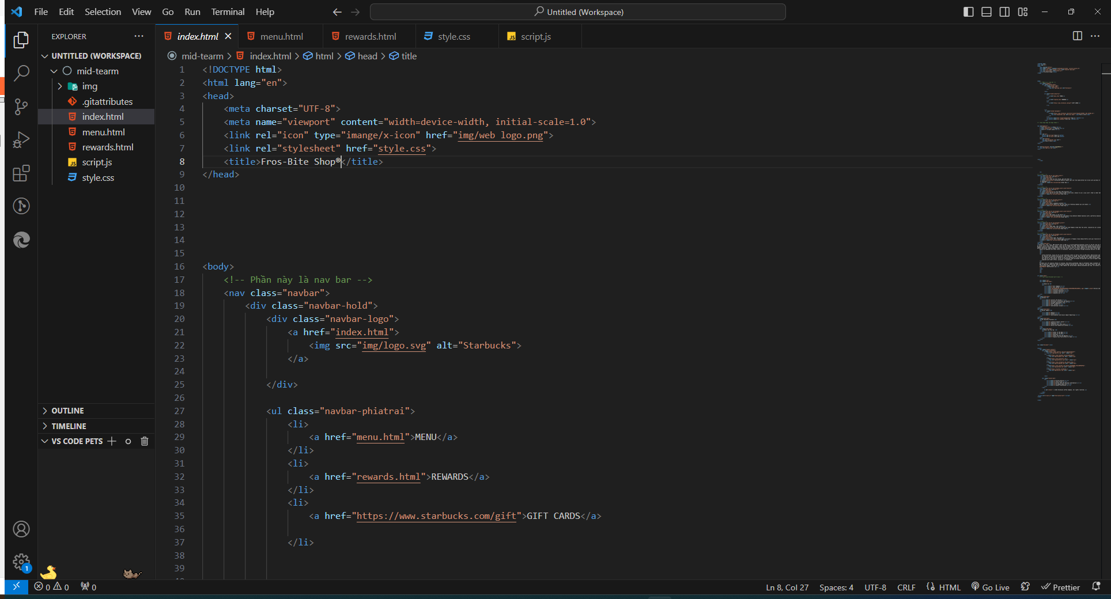

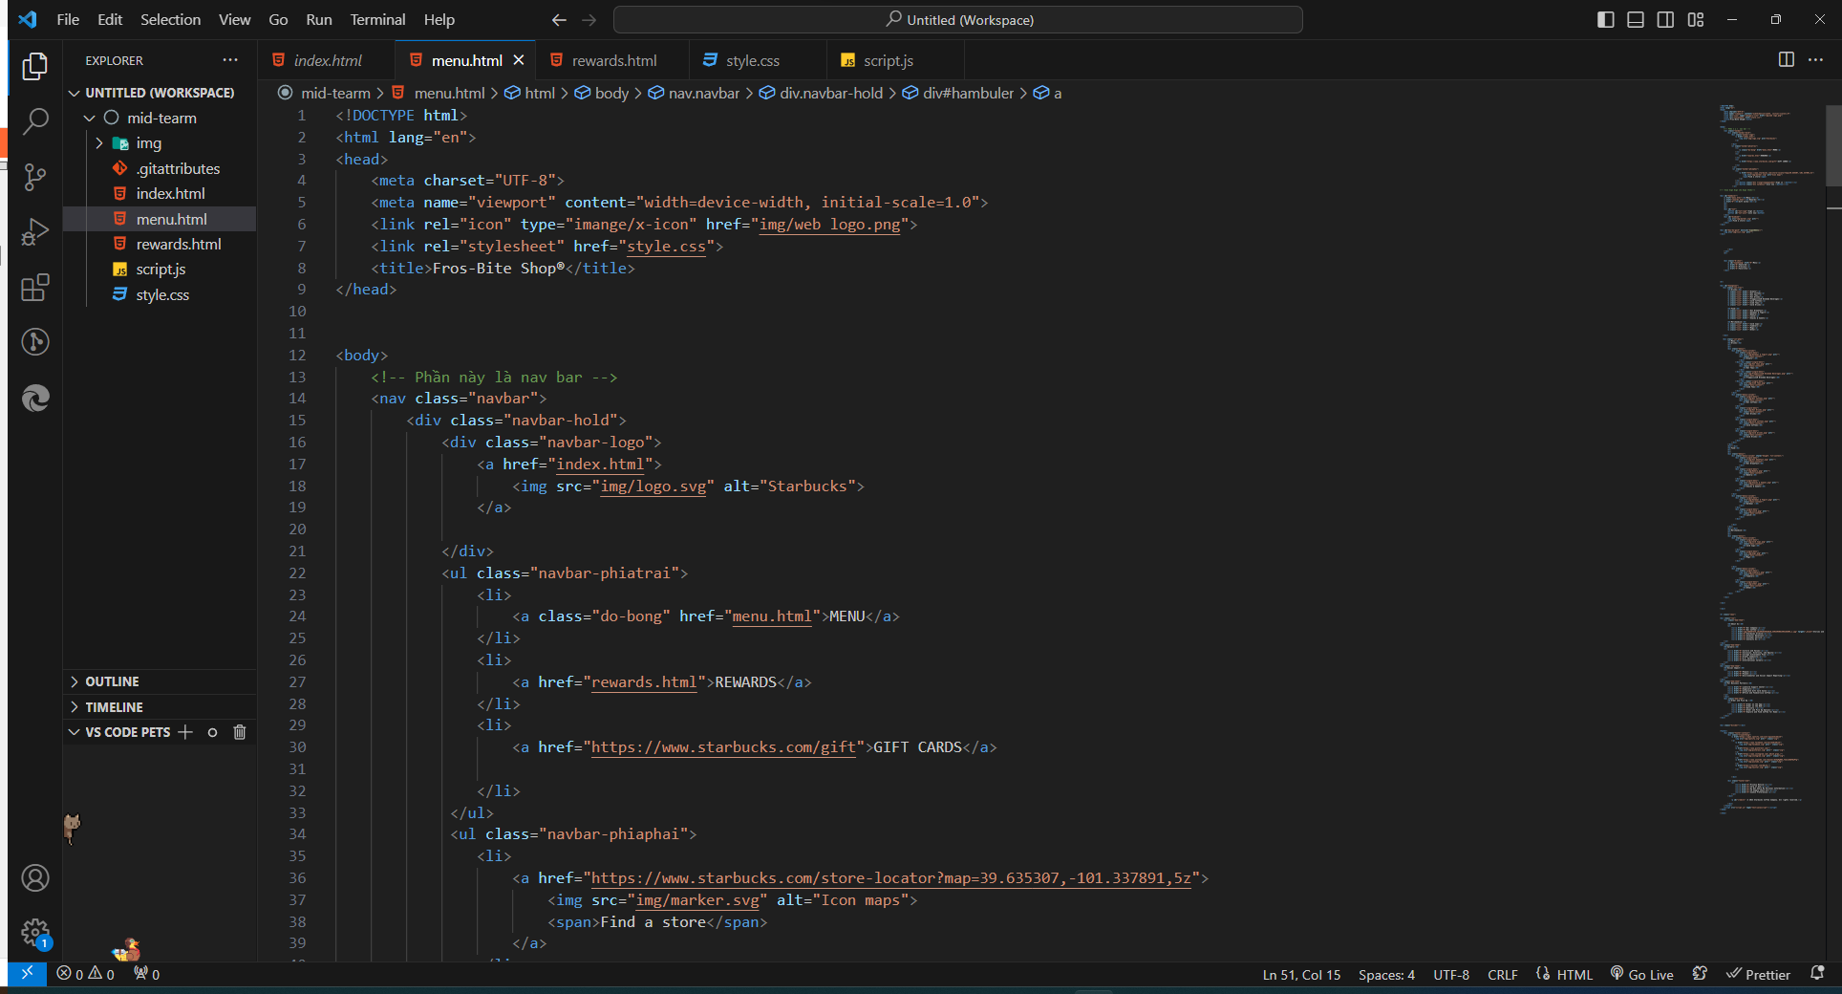

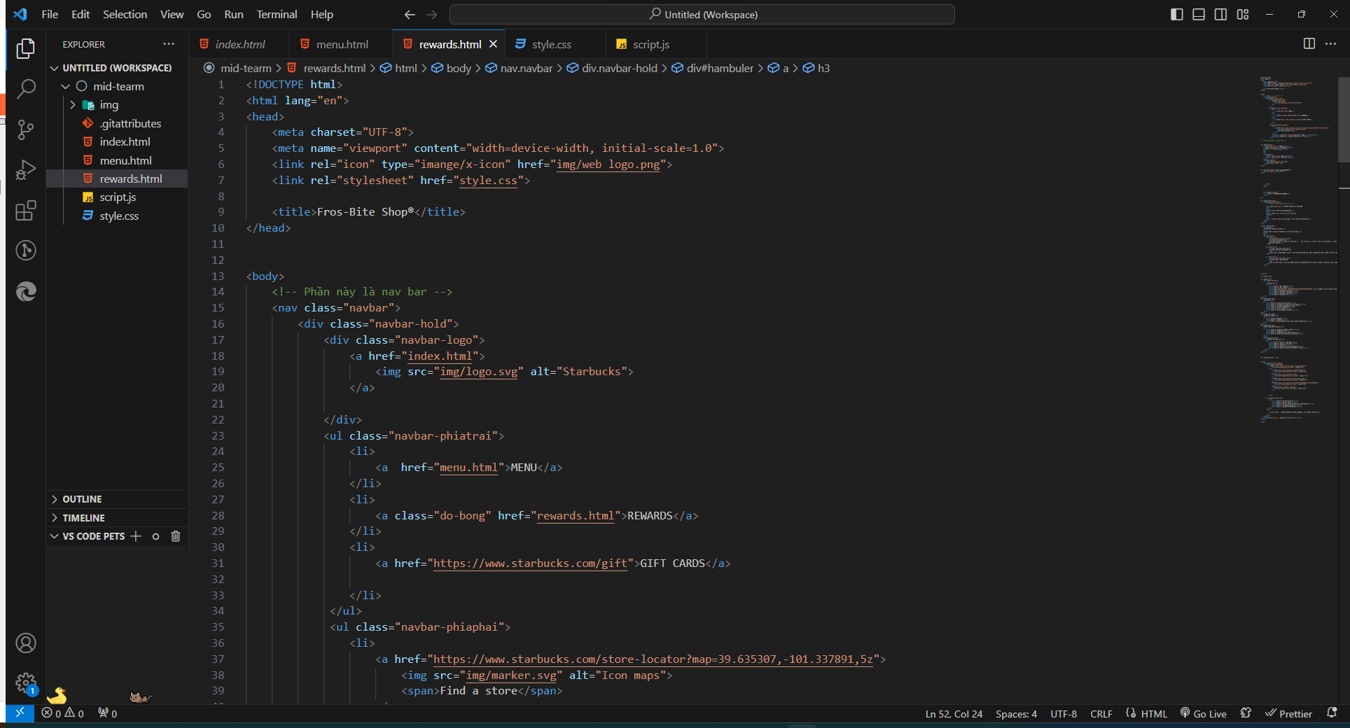

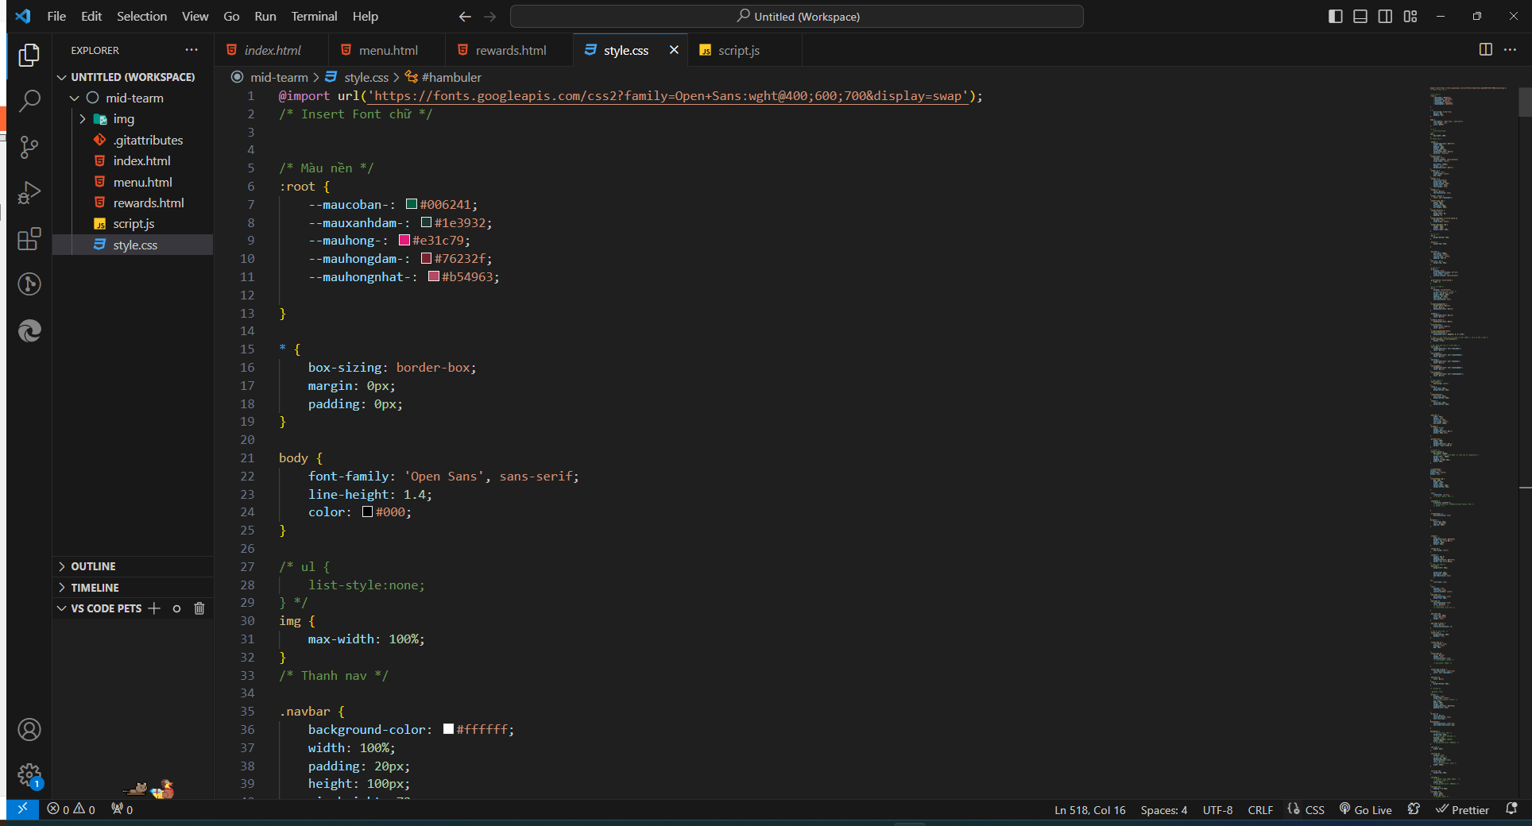

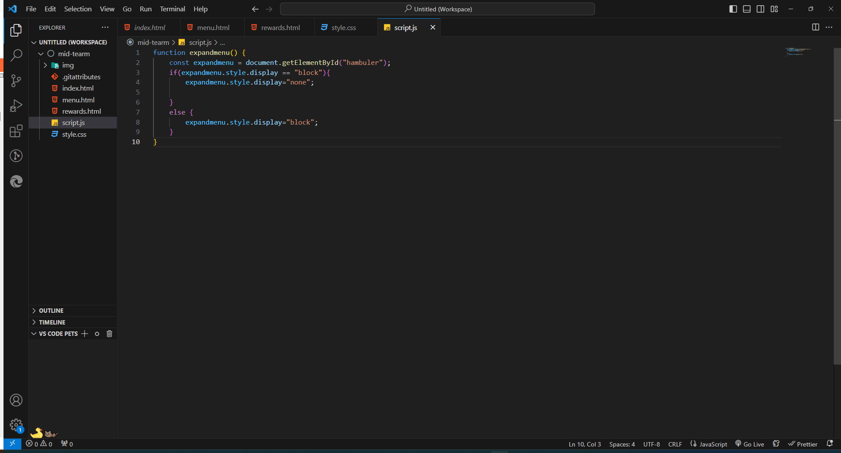

**B, Webpage**

**\*PC version:**

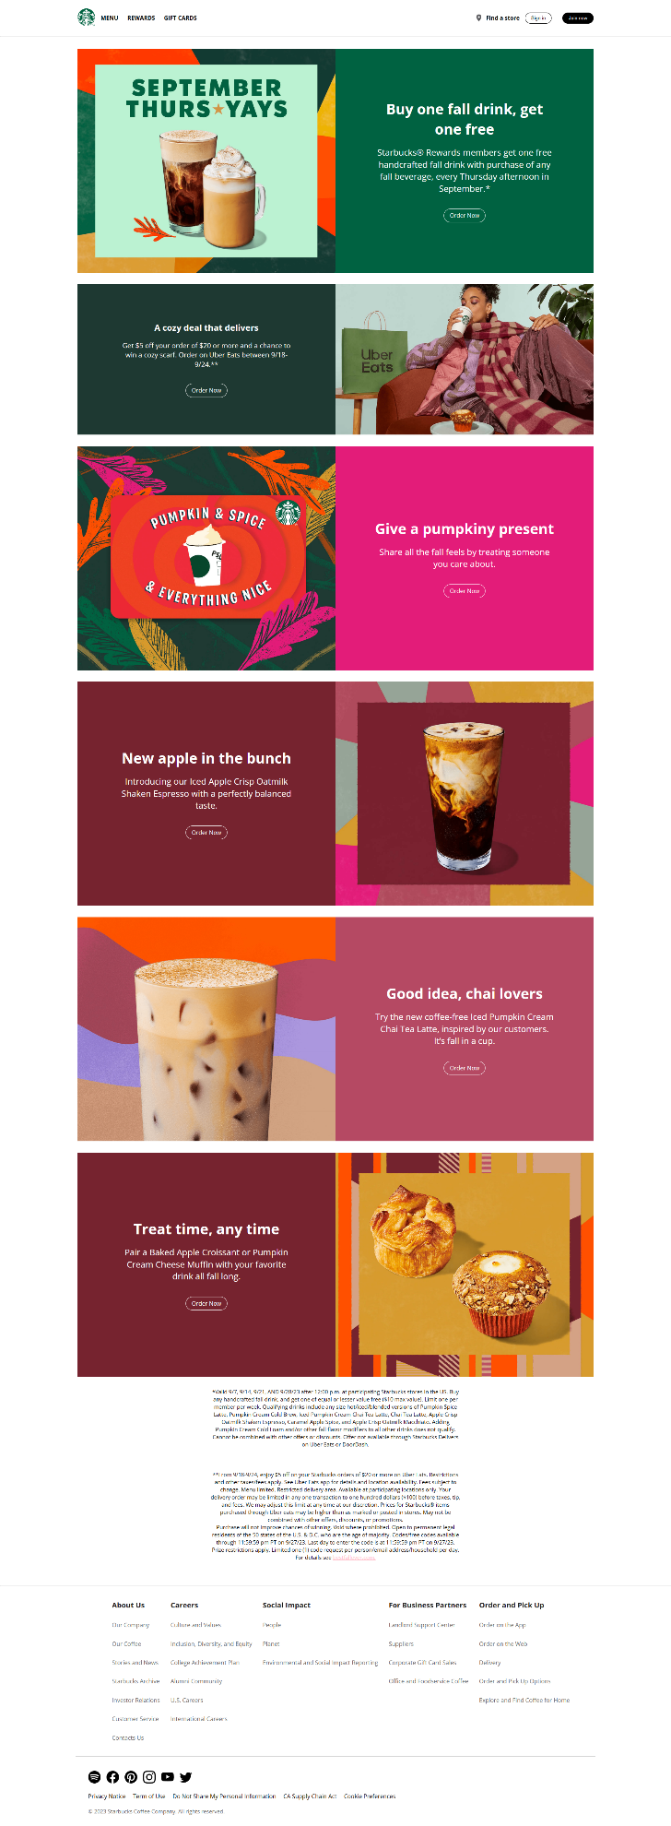

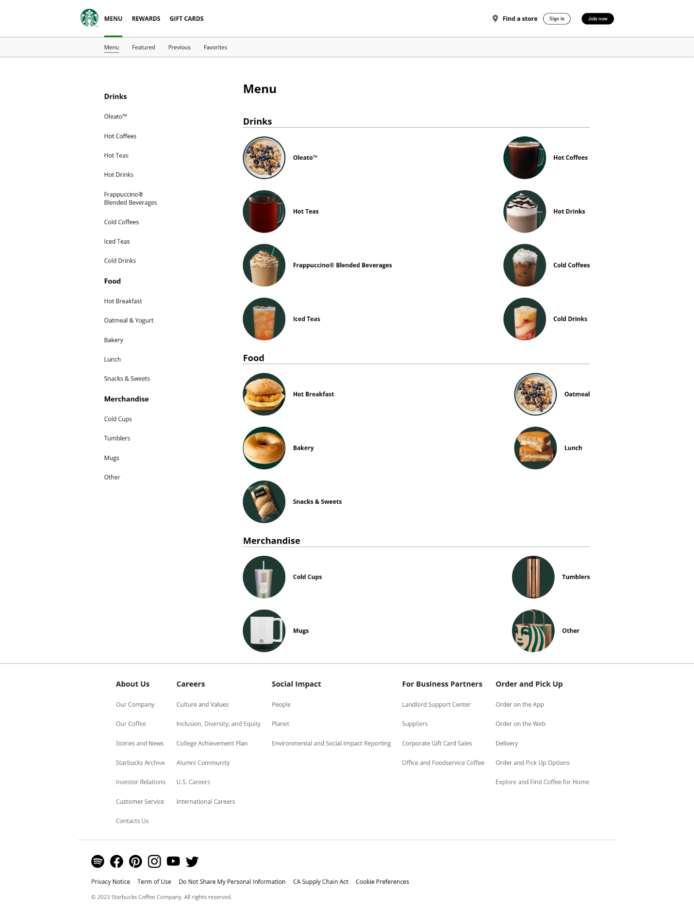

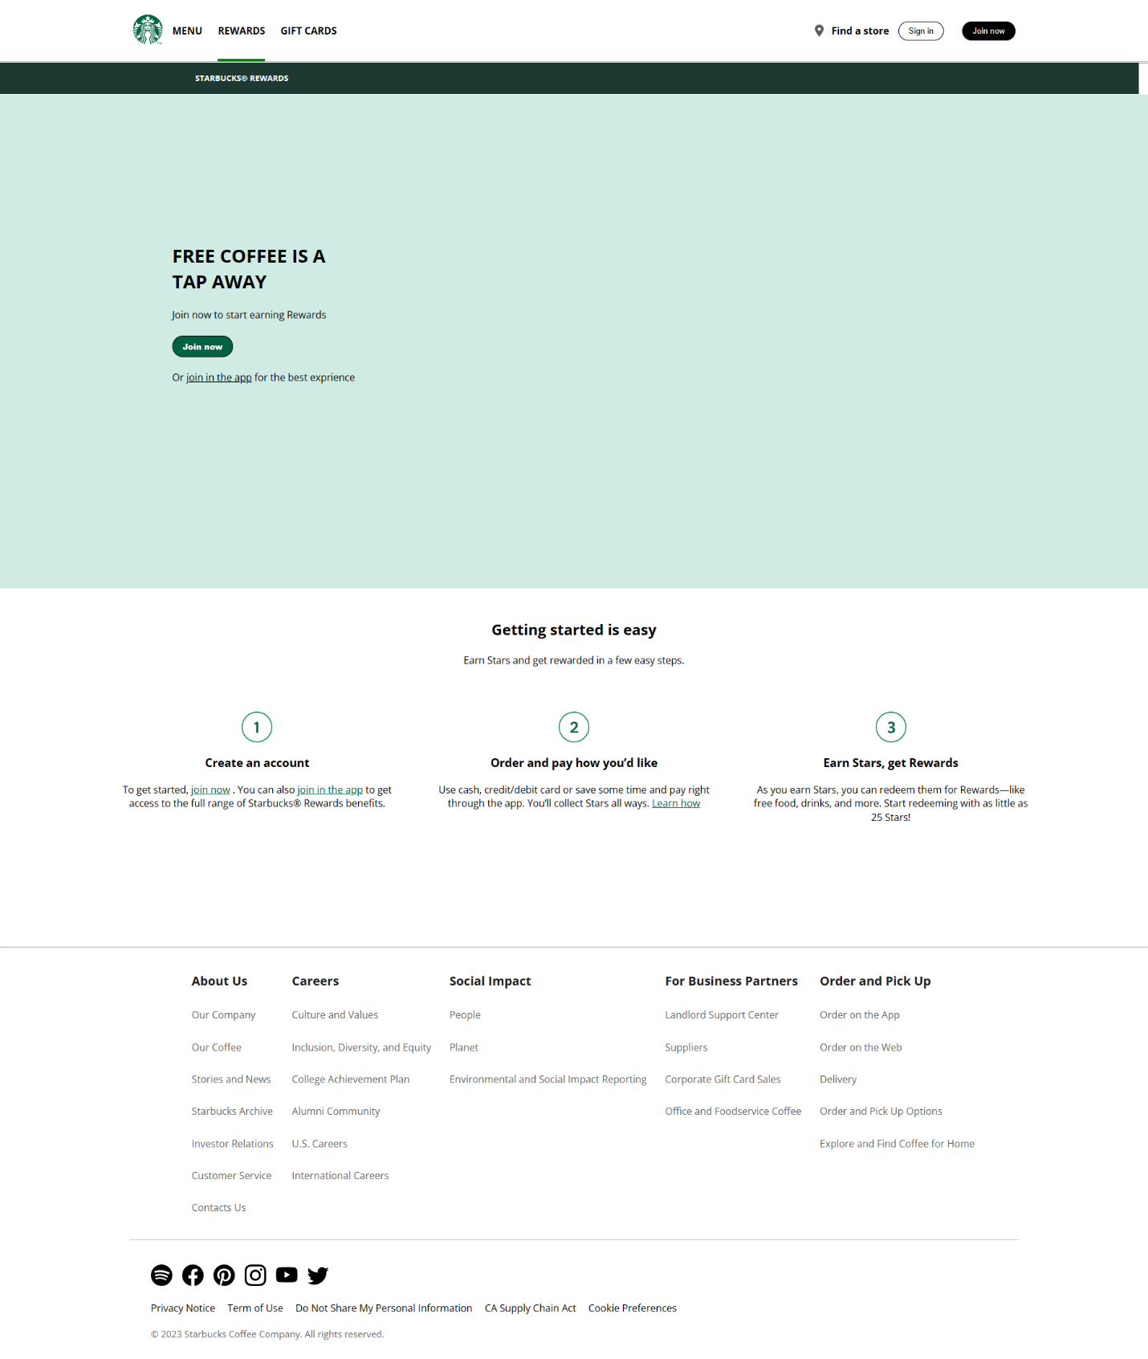

**\*Responsive version**

**   **